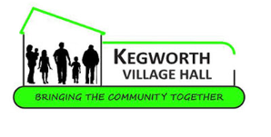
BOOKING FORM FOR CRAFTS AND TABLE TOP SALE – SATURDAY 11 OCTOBER 2025

NAME | Click or tap here to enter text.
COMPANY NAME – if any | Click or tap here to enter text.
ADDRESS | Click or tap here to enter text.
TEL NO | Click or tap here to enter text.
EMAIL ADDRESS | Click or tap here to enter text.
WEB ADDRESS – if any | Click or tap here to enter text.
NO OF TABLES REQUIRED | Choose an item.
TYPE OF GOODS TO BE SOLD | Click or tap here to enter text.
INSURANCE | Choose an item.

- As we are in the process of ensuring our records are up-to-date I would be grateful if you would forward a copy of your Public Liability insurance policy .
- If you do not hold a policy please be aware that all goods displayed/sold are at your own risk as the Village Hall cannot be held responsible for any loss or any defective goods sold, liability resting with individual stallholders.
- For those without public liability insurance for safety reasons please do not sell electrical products or consumables whilst on the Village Hall’s premises.

Confirmation of booking will be sent to you along with details of the Methods of Payment. Full payment should then be paid within one month of booking otherwise the table will then be released.
Refunds will be made up to one week prior to the Sale.

